MSc Software Development

CSC7051 Programming 2

Practical 1

**Revision Exercises**

**Exercise 1**

At ice skating competitions, a number of judges each give a skater a score. The overall score for the skater is determined by dropping the highest and lowest scores, and averaging the remaining scores. Suppose scores are given to a skater by five judges, each having a value in the range 0 to 10.

Write a program that reads the five scores and without sorting the scores, determines the overall score for the skater.

The program should have a class IceSkater consisting of

* an array of doubles to hold the five scores
* a constructor that sets the five scores
* a method to calculate and return the overall score

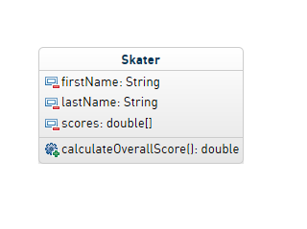

**Extensions to the program**

1. The number of possible scores is upped to 7. Update your program to cope with this.
2. Ensure validation on setting the scores. (0 to 10).

**Exercise 2**

A palindrome is a word or phrase that reads the same backwards as it does forwards, for example MADAM I’M ADAM. Palindromes can be very short. The word POP is a palindrome. They can also be long such as A MAN A PLAN A CANAL – PANAMA!

Write a program to check if a given word is a palindrome. For the purpose of this exercise, assume the text does not contain punctuation and spaces, and that all letters are in uppercase. Do most of the work within a class ***CheckPalindrome***.

**Updates ...**

1. Update the program to check if a phrase is a palindrome e.g. **A MAN A PLAN A CANAL** PANAMA
2. Update the program to also consider upper and lower case letters. E.g. **No x in Nixon**